**1.Querying Data by Using Joins and Subqueries**

1.SQL JOINS:

* Left-Inner Join
* Left-Outer Join
* Right-Inner Join
* Right-Outer Join

First created a database named assessment and then we used that database to store the data.

Later created tables named studentsdetails and marksdetails in database to do joins

* Left-Inner Join

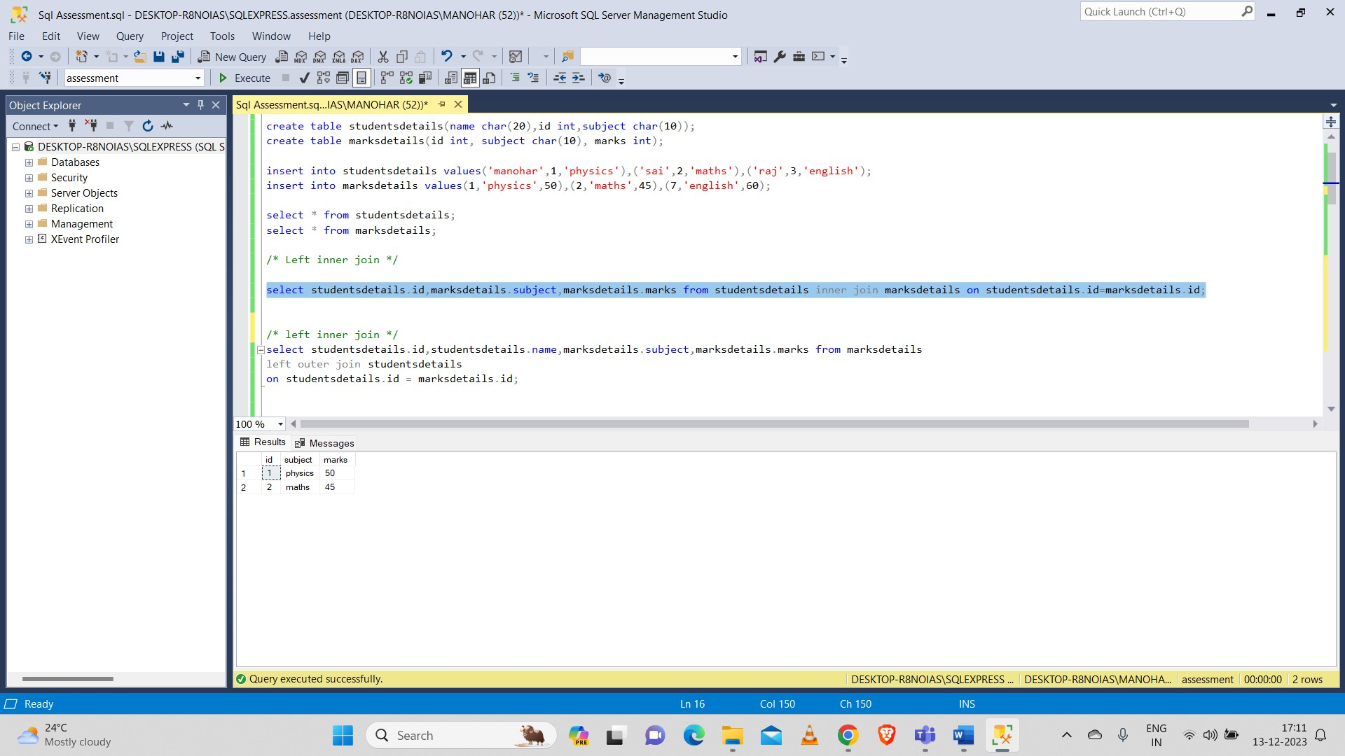

* Left-Outer Join

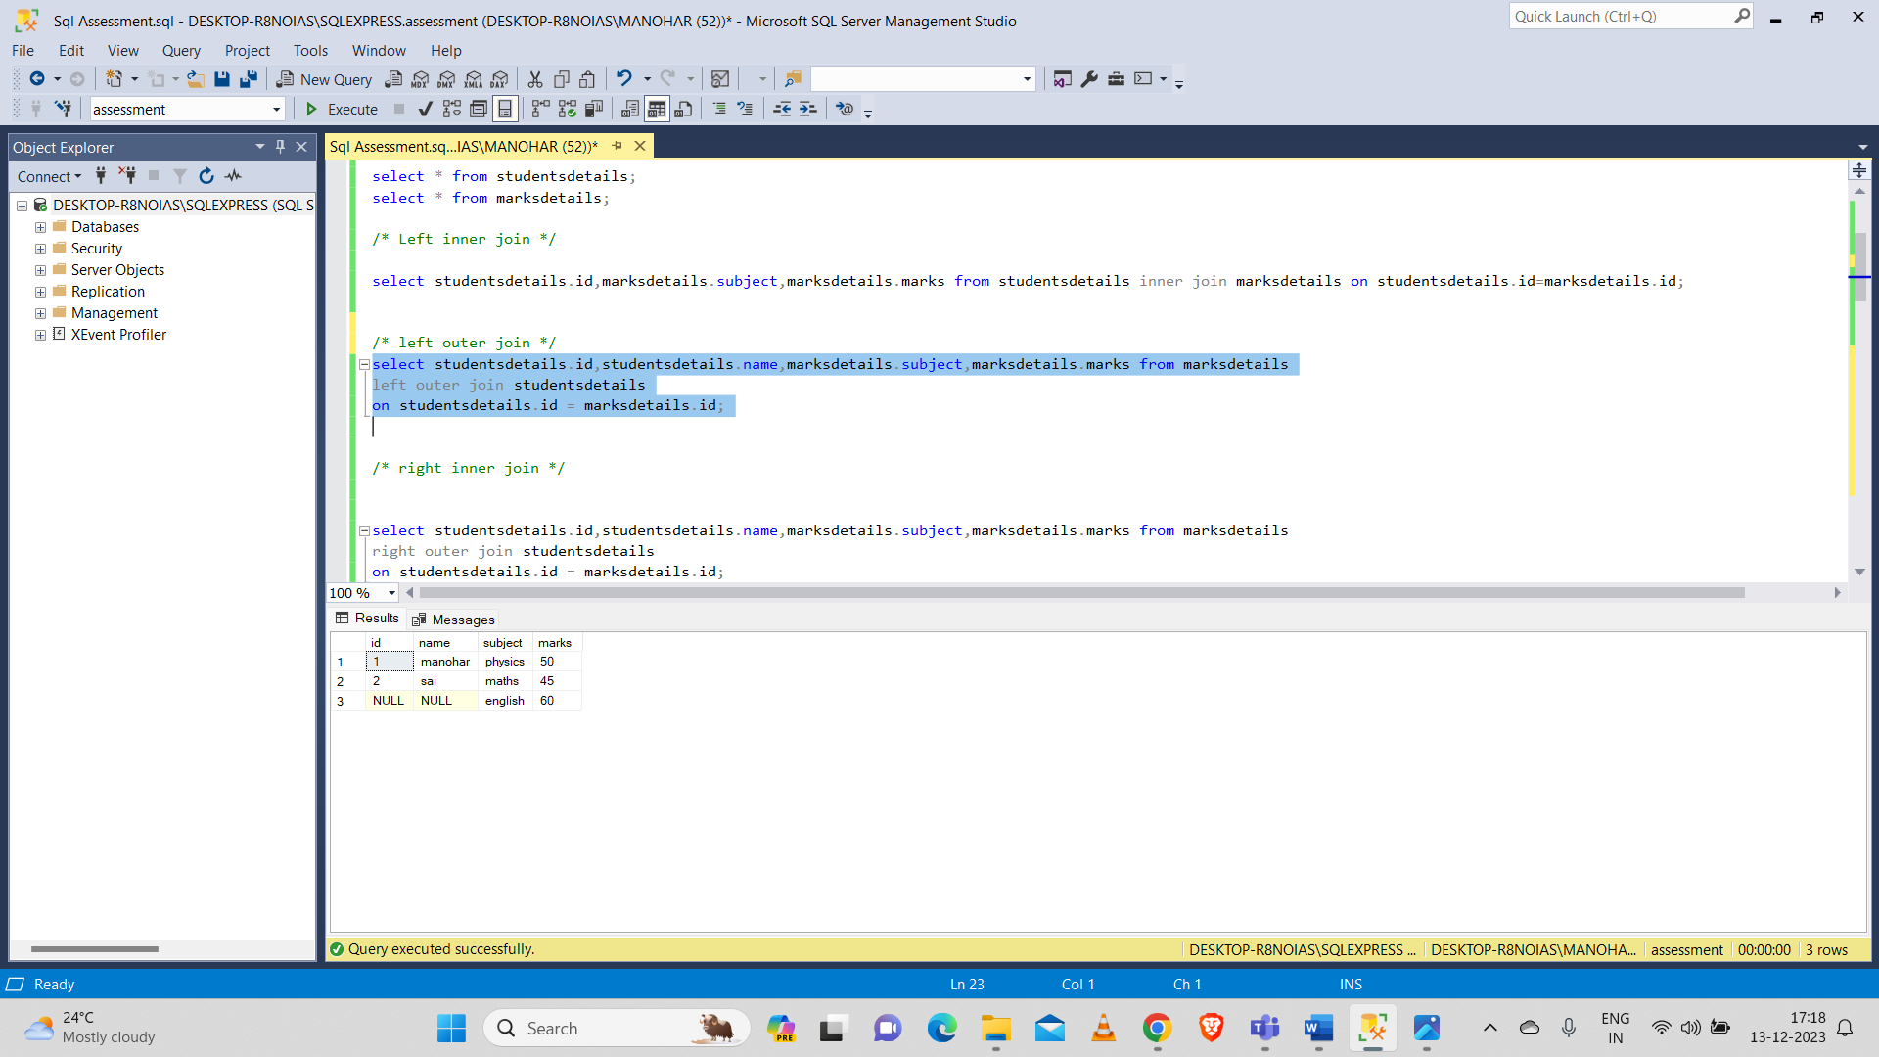

* Right-Inner Join

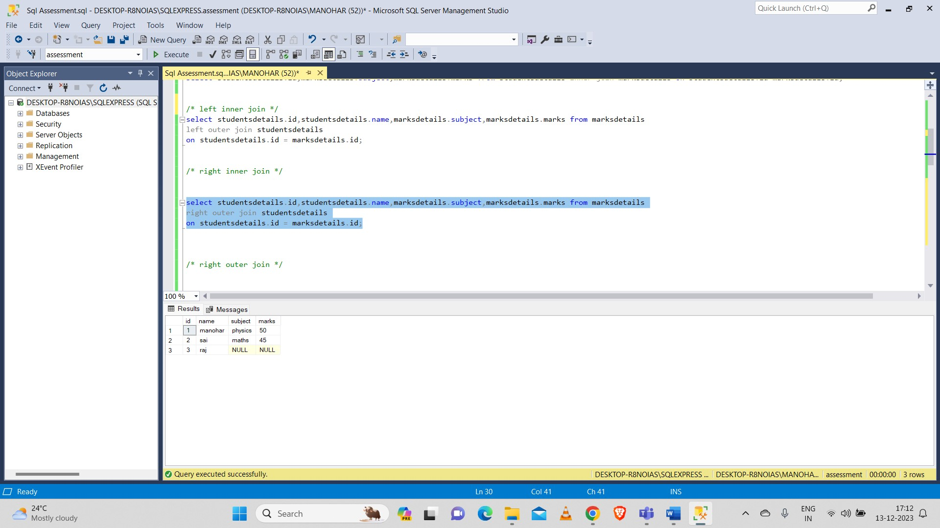

* Right-Outer Join

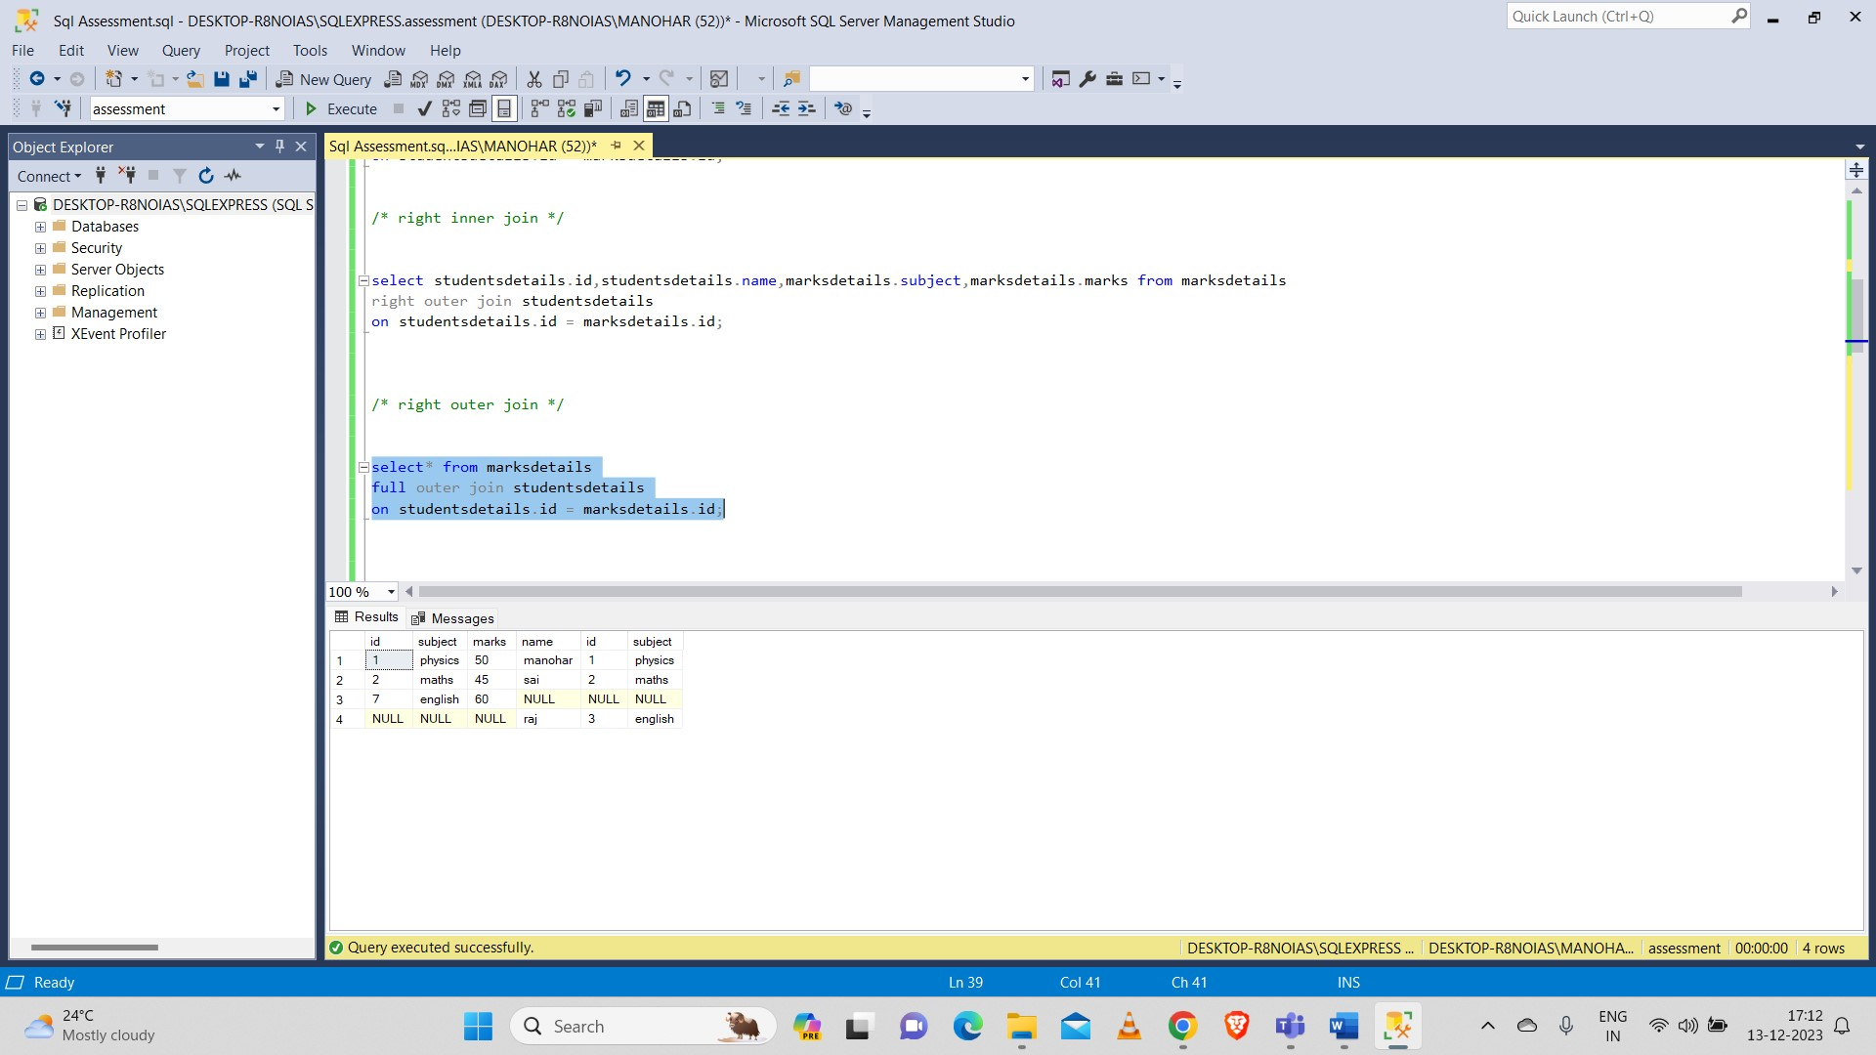

Now I created two more tables named student and section into database to perforn subqueries.

* Select:

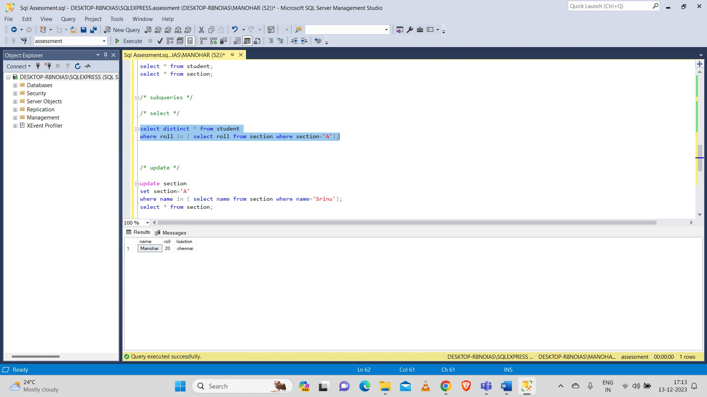

* Update:

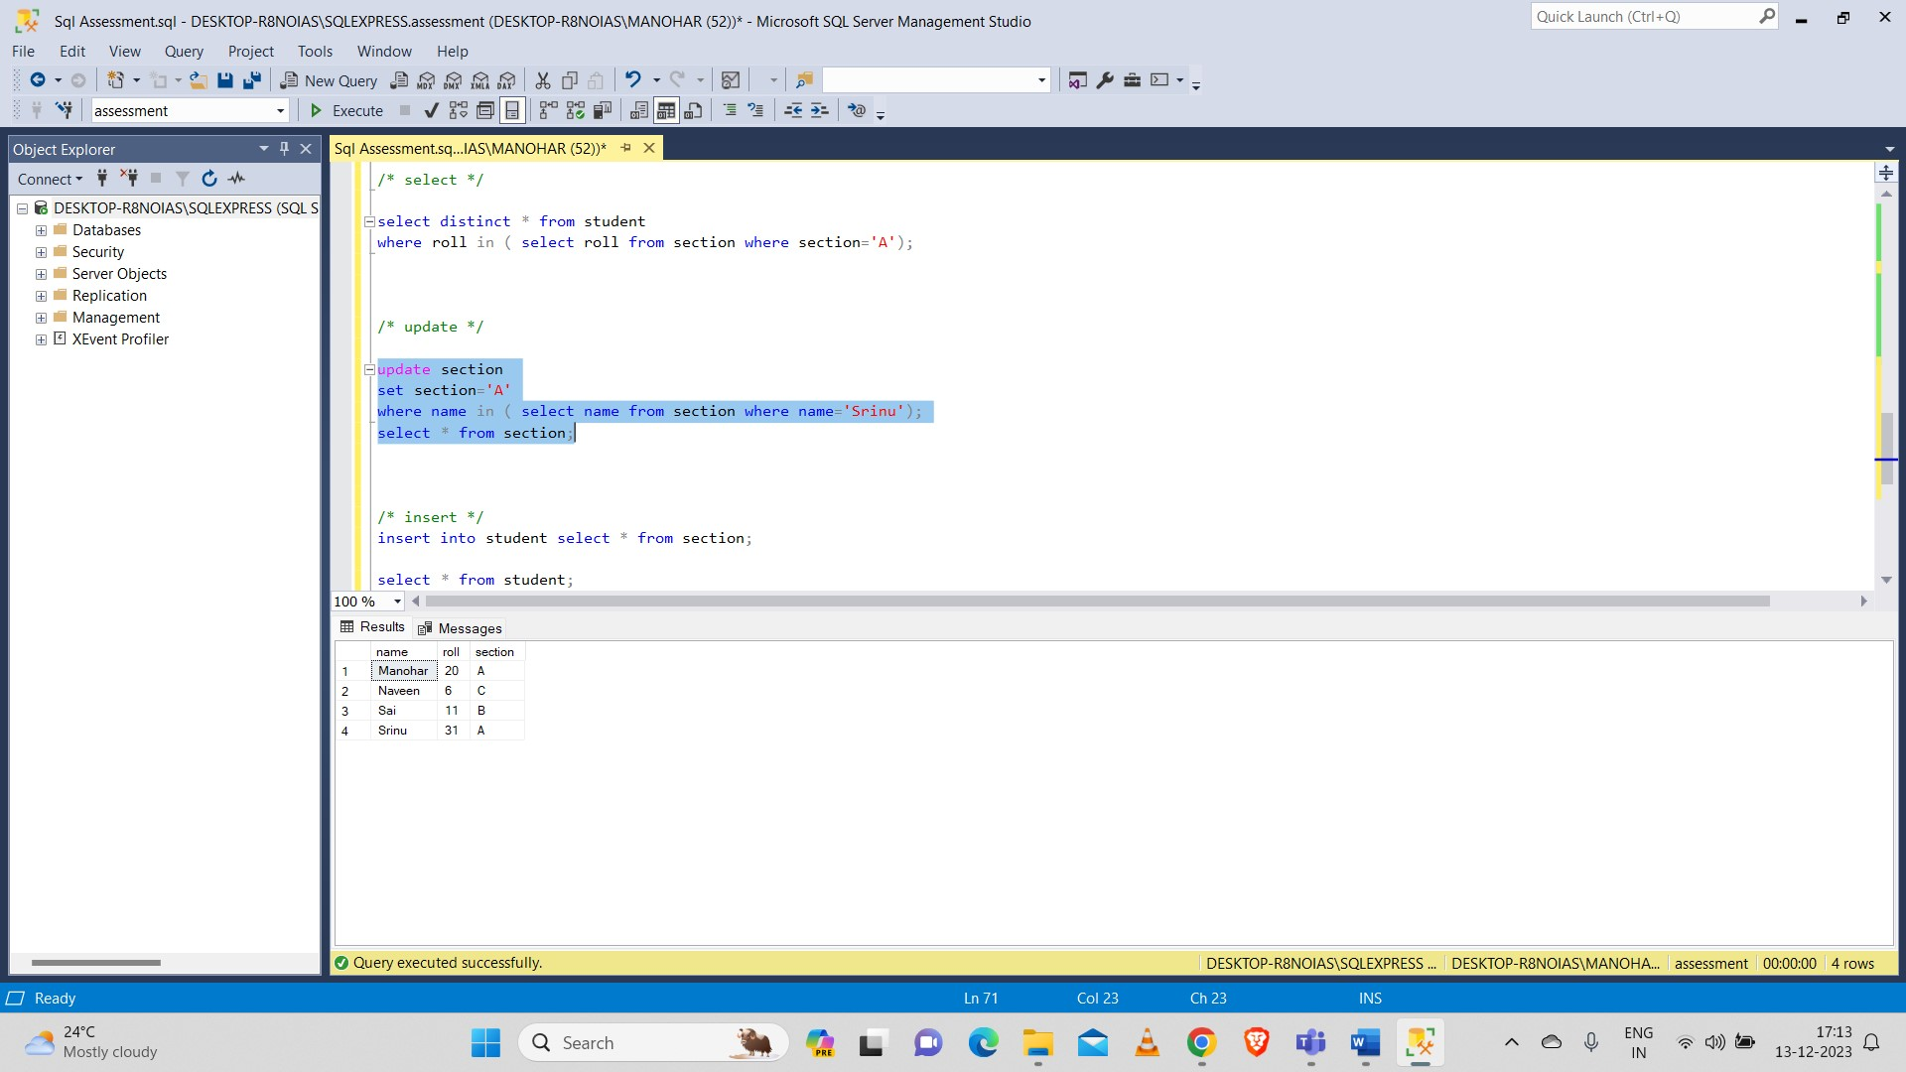

* Insert:

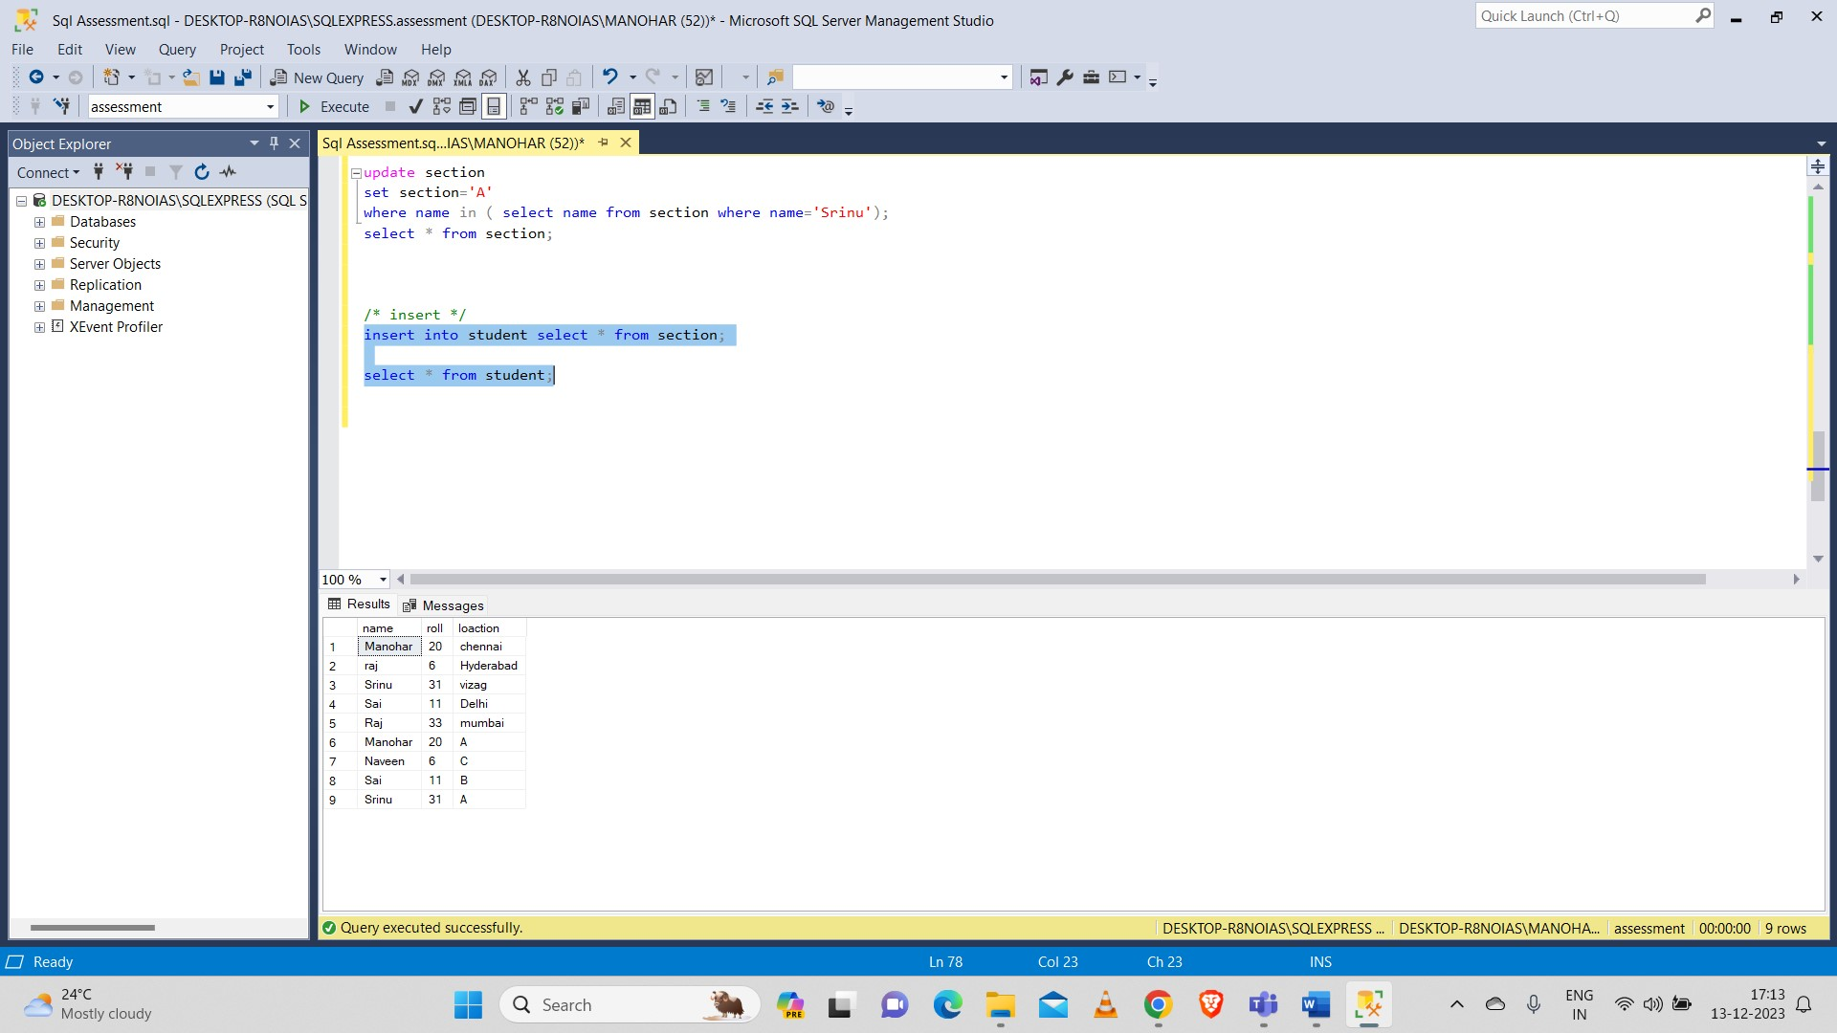

**2.Manipulate data by using sql commands using groupby and having clause.**

### DML (Data Manipulation Language) commands

* 1. insert
  2. Update
  3. Delete

First created table and performed Data manipulation commands on the table.

* **Insert:**

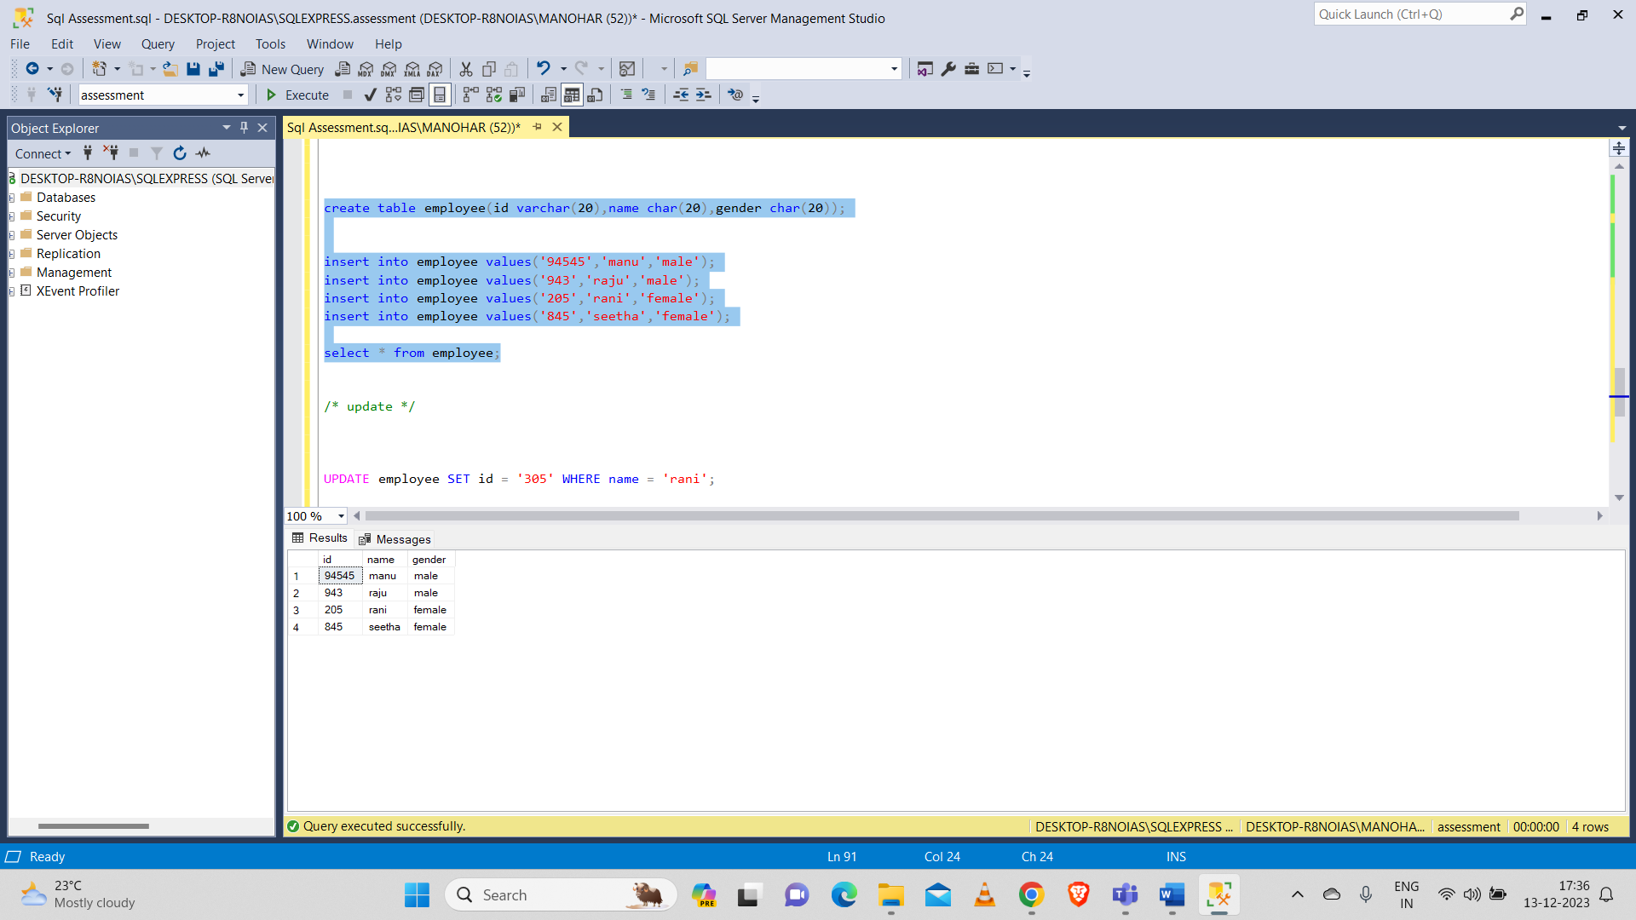

* **Update:**

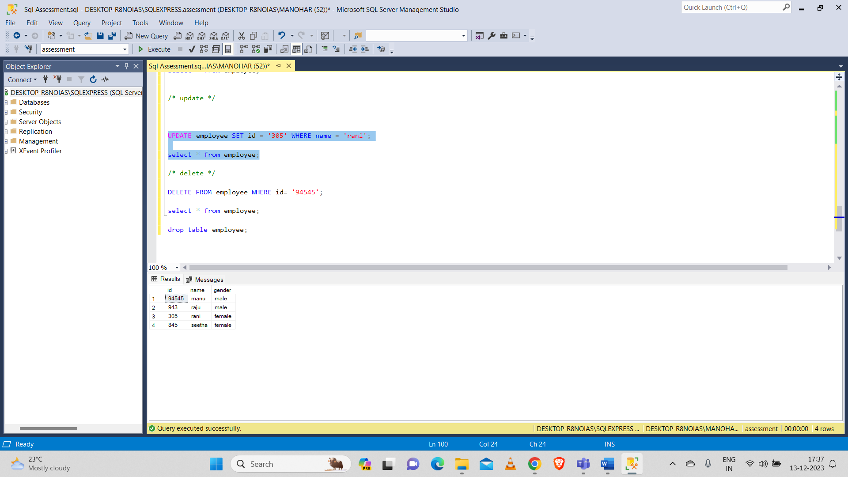

* **Delete:**

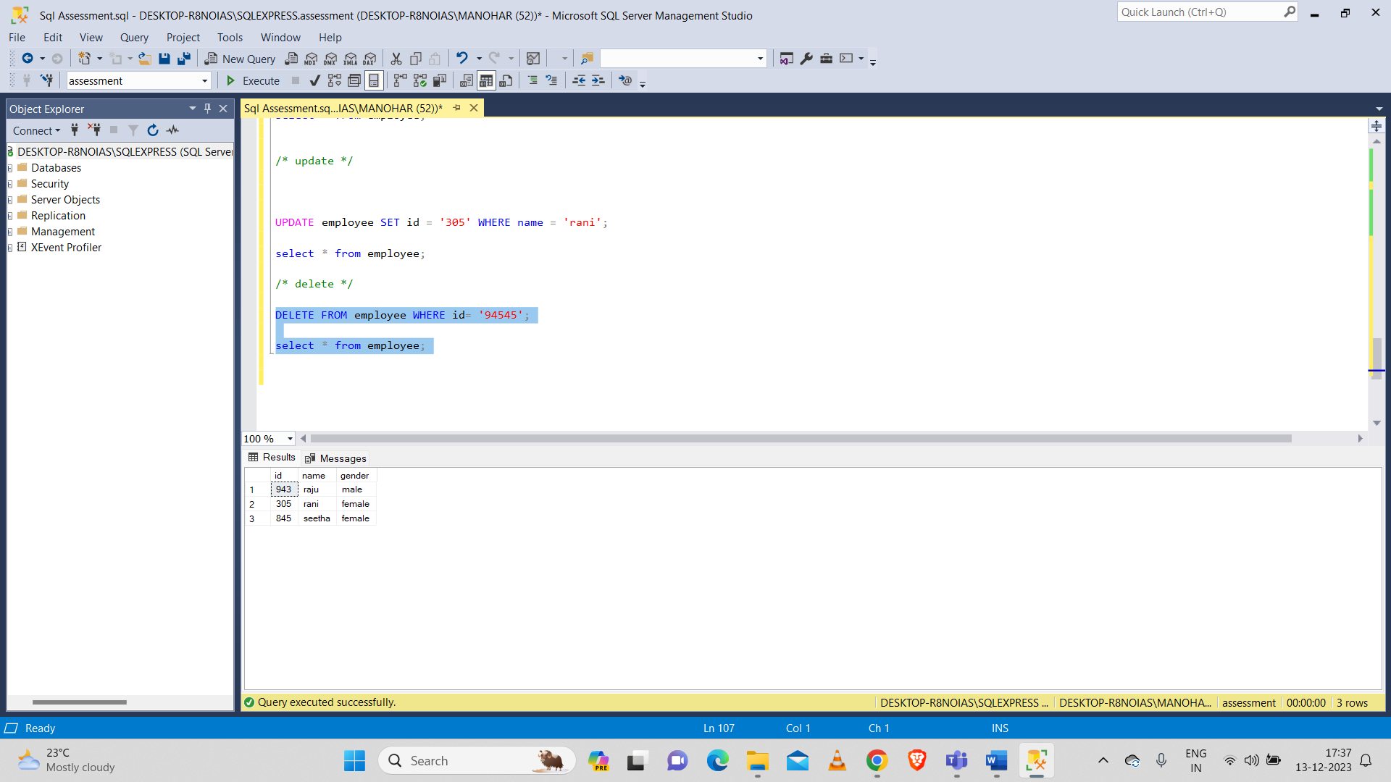

**Group by and having clause:**

